## Module 1. Business game “Marketing and Sales”

Welcome to the world of retail trade!

Each participant in the business simulation gets three stores in different regions at the beginning of the game. The regions differ in the number of population, income level of the population, demand patterns, and macroeconomic indicators. Players need to analyze the market, their competitiveness, and make decisions to focus on certain market sectors or to diversify. To develop and scale their business, players will have to understand the structure of demand and its elasticity, marketing and sales promotion tools, and manage all components of the marketing mix (Product, Place, Price, Promotion) to maximize sales and profits compared to competitors.

**Goals (Example)**

* Develop your retail network: increase the number of stores from 3 to 6, each of which should be profitable.
* Maximize sales profitability and profit from the distribution network, outperforming other group members in these indicators.
* Take the top line in the ranking in terms of retail chain turnover.
* Take the top line of the ranking in terms of the amount of profit earned.

**Location**

To create a balanced business environment there will be a combination of three regions chosen – Antwerp, Jacksonville, Hamburg (for intensive mode) and Manchester, Mexico City, Toronto (for classic mode). Once chosen, the combination cannot be changed, therefore you will have to develop your retail business in the given regions.

**Company**

At the beginning of your game, you will receive:

* **Cash** – 10 000 000 in virtual currency.

* **An office**, to manage administrative tasks of your current retail network. Each region will receive a separate office.

* **3 clothing and footwear stores** with the goods of approximate value of $ 1,000,000 each.

* Help from an experienced manager to increase the efficiency of employees of the office and top management.

* 30 qualification points in all available categories (management, production, etc.)

## Expertise

* Marketing, Market analysis.

Product mix.



* Pricing.

* Advertising.

* Supply chain.

Size and location of the present and new stores.



* HR.

Administration.



* Logistics.

* Decision making.

* Strategic management.

## Module 2. Hint Questions

Virtonomics is a vast environment with a large number of operations, processes, and variables. To give you certain hints about where to look and what to consider, we will ask you certain questions. Take them into consideration during the gameplay.

**Store**

* Does the location and the size of the store match the prices and quality of the wares?
* How optimal is the use of your trade space?
* Have you considered increasing the space of the store and hiring new workers to avoid lines?
* Have you considered opening a second or a third store in the same city to cover a different district?

**Price**

* Are your prices affordable, considering the average salary and wealth index of the local population?
* What is the best price and quality combination?
* Have you noticed that the average price of the product in a city is affected by the amount of sold products, but not the prices placed in the Trade Hall?

**Products / Goods**

* How popular is the product in the local market?
* How profitable is it? How big is the margin, compared to other products? What is the preferred quality by the consumers?
* How many competitors are there in the market?
* Have you considered mixing different categories of the products?
* What is your optimal category mix in the store? What are your best sellers?

**HR**

* Have you considered hiring more employees compared to a minimum recommendation?
* What is the impact of the qualification of your employees on the popularity of the store?

**Advertising**

* Have you noticed that not all store visitors are buyers?
* Have you considered increasing your advertising budget to attract more visitors? How efficient is your advertising?
* Is your store big enough to serve the amount of customers attracted by advertising?

**Supply Chain**

* How often do you run out of goods to sell?
* How big is your reserve of goods?
* How often do you review the suppliers’ prices and search for new ones?

**Office**

* Is the amount of employees in the office optimal to administer the work in all of your
* subsidiaries?
* Is the efficiency of your main office always at 100%?
* Have you considered buying higher quality computers for the employees of the office?

# Module 3. Assess your new competencies in the retail business

## What are my retail store business results at the end of the business game?

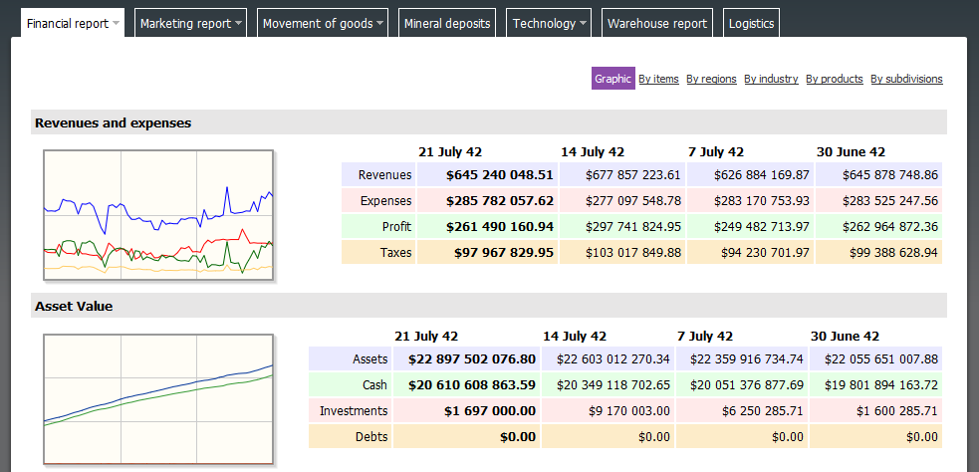

**What are the financial results in each of my stores?**

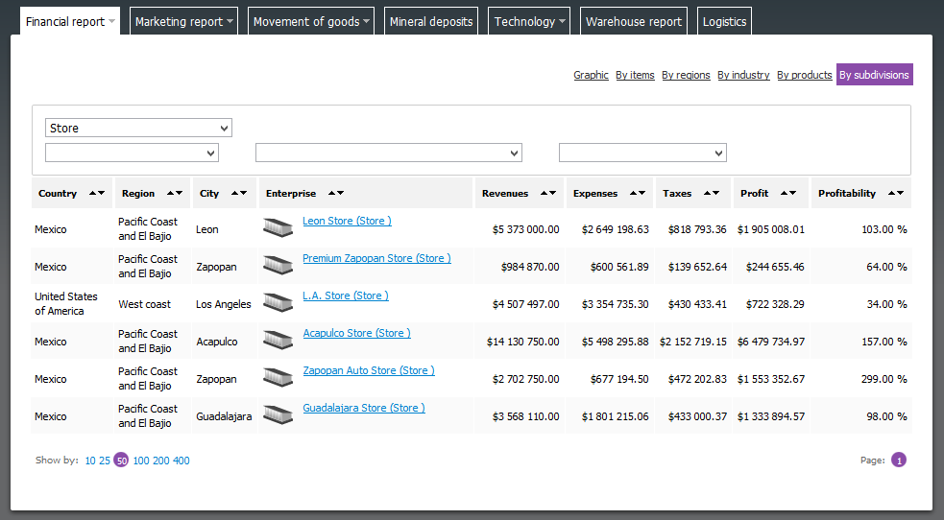

## What have I done/failed to do to improve my retail business?

* Marketing decisions (Place, Product, Price, Promotion):
* Supply management decisions:



* Resource (HR, FM, SM, logistics, etc.) management decisions:

## Self-assessment - my learning experience:

* Marketing and context analysis –
* Supply chain management –
* Decision making –
* Establishing of product, place, pricing and promotion –
* Logistics -
* International trade (customs, taxes, etc.) -
* Personnel management -
* Investment and finance management -

