# Module 1. Business game “Growth and scaling”

The business simulation is aimed at small business owners planning to grow and enter new markets. In the game you are the owner of a small shoe factory and a small store, working on the local market. But you are ambitious and plan to turn a small family business into a large international brand with production and sales in different countries. 1. Increase sales and production in the local market. 2. Enter new promising markets, pump up your brand, and increase sales and margins. 3. Find optimal markets to expand production. Earn $100,000,000 and beat the competition.

## The goals of the game (examples)

Develop and grow your virtual business of shoe development and production - maintain the current structure of subsidiaries or increase it in size.



* Develop and grow your virtual business of shoe retail from 1 to 3 stores and make them all profitable.

**Location**

A random region for your business will be chosen. Once chosen, it cannot be changed, therefore you will have to develop your business in the given region.

**The Business:**

At the beginning of your game, you will receive:

* **Cash** – 10 000 000 in virtual currency.

* **An office** is necessary to manage the administrative tasks of your current virtual business. You will receive 4 active workplaces - 4 employees and 4 computers.

* In the **chemical factory,** the rubber for your shoes is produced. You will find 50 active workplaces (200 units of equipment and 50 workers), and a certain amount of raw materials to keep the production running.

* In a **shoe factory** employees will manufacture shoes. You will receive 50 active workplaces (100 units of equipment and 50 workers), and a certain amount of raw materials to keep the production running.

* An apparel **store** where you can sell your shoes and certain additional wares. You will find inside goods of an approximate value of $ 2 000 000.

* **Technology level**. The level of technology installed in all manufacturing subsidiaries is **1**. It will allow you to create goods of maximum quality of **1**.

* Your (top manager) **qualification** will be increased by 30 points in all categories (management, production, etc.) from the very start of the game.

* Help from an experienced manager to increase the efficiency of the office and top management employees for the first 10 turns.

## Management Areas

Market analysis.

* Production Management.

* R&D.

* Supply chain.

* Product mix.

* Pricing.

* Advertising.

* Choose the size and location of the present and new stores.

* HR.

Administration.



* Logistics.

* Decision making.

* Planning and strategic management.

# Module 2. Hint questions

Virtonomics is a vast environment with a large number of simulated business operations, processes, and variables. To give you certain hints about where to look and what to consider, we will ask you certain questions. Take them into consideration during the gameplay.

**Factory / Plant**

* Have you noticed that even if you exceed the recommended quality of materials, equipment, and qualifications of employees, the end production quality will not exceed the value given by the technology level?
* Have you taken into consideration the difference in logistics terms (equipment and employees vs. parts and supplies) before expanding the scale of the manufacturing subsidiary?
* Have you considered changing the specialization of the factory to match the dynamics of the demand in the market?

**Store**

* Does the location and the size of the store match the prices and quality of the wares? How optimal is the use of your trade space?
* Have you considered increasing the space of the store and hiring new workers to avoid lines?
* Have you considered opening a second or a third store in the same city to cover a different district?

**Price**

* Are your prices affordable, considering the average salary and wealth index? What is the best price and quality combination?
* Have you noticed that the average price of the product in a city is affected by the amount of sold products, but not the prices placed in the Trade Hall?

**Products / Goods**

* How popular is the product in the local market?
* How profitable is it? How big is the margin, compared to other products? What is the preferred quality by the consumers?
* How many competitors are there in the market?
* Have you considered mixing different categories of the products?
* What is your optimal category mix in the store? What are your best sellers?

**Human Resources**

* Have you considered hiring more employees compared to a minimum recommendation? What is the impact of the qualification of your employees on the popularity of the store?

## Advertising

* Have you noticed that not all store visitors are buyers?
* Have you considered increasing your advertising budget to attract more visitors? How efficient is your advertising?
* Is your store big enough to serve the amount of customers attracted by advertising?

## Supply chain

* How often do you run out of goods to sell? How big is your reserve of goods?
* How often do you review the suppliers’ prices and search for new ones?

**Office**

* Is the number of employees in the office optimal to administer the work in all of your subsidiaries?
* Is the efficiency of your main office always at 100%?
* Have you considered buying higher quality computers for the employees of the office?

# Module 3. Assess your new competencies

## What are the results of my virtual business at the end of the game?

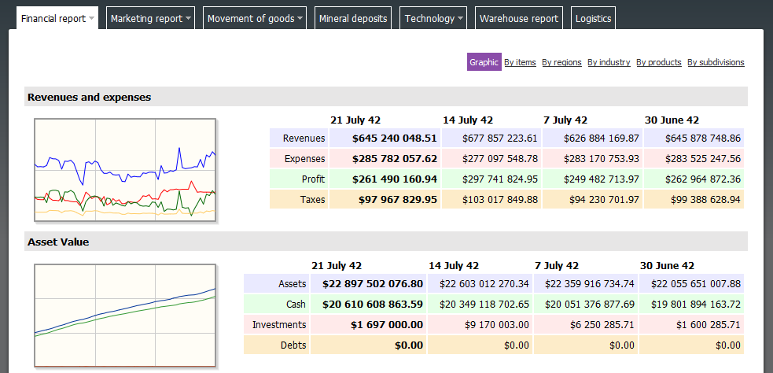

**What are the financial results of each of my subsidiaries?**

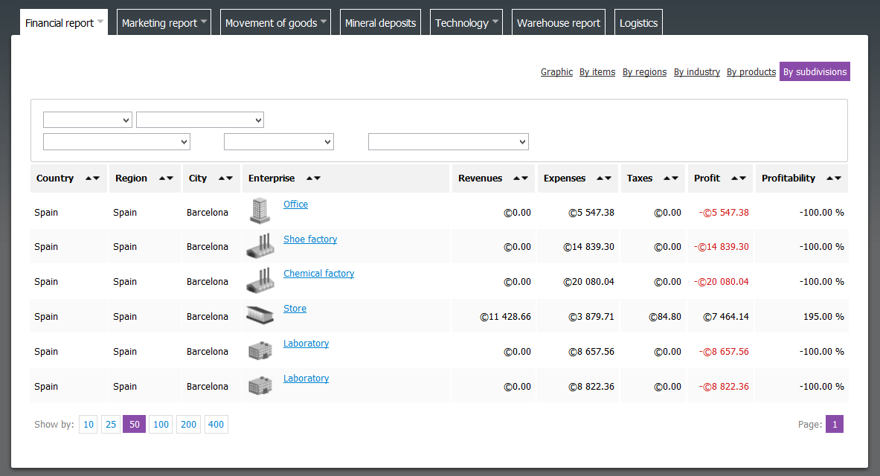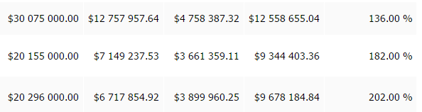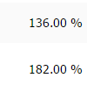

## What have I done/failed to do to improve my virtual business?

* Production management decisions:
* Supply management decisions:



* Marketing decisions (Place, Product, Price, Promotion):
* Resource management decisions:

## Self-assessment - my learning experience:

* Marketing analysis –
* Supply chain management –
* Decision making –
* Production management –
* Quality management –
* Establishing of product, place, pricing and promotion –
* Logistics -
* International trade (customs, taxes, etc.) -
* Personnel management -
* Investment and finance management -
* R&D -
* Value chain management -