# Module 1. Business game “Crisis Terminator”

Each participant in the business simulation “Crisis Terminator” plays the role of the CEO of a trading and manufacturing company in a difficult financial situation. In conditions of limited resources and time, players need to analyze the state of their companies, correct key problems, analyze the market, develop and implement an anti-crisis plan, and put the company on a path of sustainable growth. The goal of the game is to eliminate mistakes made by previous managers, optimize all business processes, increase the efficiency of company management, enter new markets and, in the allotted time, earn more profit than competitors.

## The goals of the game (Examples)

* Conduct a business audit, correct identified problems, and lead the company out of a crisis.
* Achieve growing profits and increase profitability
* Earn the maximum amount of profit during the allotted game time among all group members

**Location**

You will manage an international company, as the whole business is positioned in two regions. Its position cannot be changed, therefore you will have to develop your business in the given regions.

**Your business**

At the beginning of your game, you will receive:

* **Cash** – 2 000 000 in virtual currency.

* **An office** is necessary to manage the administrative tasks of your current virtual business. The companies you manage are positioned in two regions, thus you will have **two offices**. Each will have 4 active workplaces - 4 employees and 4 computers.

* **Apparel store** with the goods

* **Grocery store** with the goods

* **Motorcycle store** with the goods

* In the **Bread factory,** the bread is backed. You will find 10 active workplaces with 10 units of equipment and 10 employees. A certain amount of materials needed for production is available as well.

* **Technology level**. The level of technology installed in the manufacturing subsidiary is **4**. It will allow you to create goods of a maximum quality of **6.06**.

* Each business skill of your game character is upgraded to 30 points.

* Help from an experienced manager to increase the efficiency of employees of the office and top management for the first 10 turns.

Some of the subsidiaries require urgent changes. Otherwise, their losses will bring your business to bankruptcy. Find them and optimize their performance.

## Expertise

Market analysis.

* Production management.

* Supply chain.

Product mix.



* Pricing.

* Advertising.

* Choose the size and location of the present and new stores.

* HR.

Administration.



* Logistics.

* Decision making.

* Planning and strategic management.

# Module 2. Hint Questions

Virtonomics is a vast environment with a large number of simulated business operations, processes, and variables. To give you certain hints about where to look and what to consider, we will ask you certain questions. Take them into consideration during the gameplay.

**Company management**

* Have you tried categorizing problems within your subsidiaries to determine the ones that need to be solved first?
* Have you tried making a plan of action to manage your time and business efficiently? Have identified the categories and industries that will bring you the most profit with the least expenses and in the shortest time?
* Where can you achieve the biggest margin?
* Have you tried analyzing the competitors? How about learning from market leaders?

**Store**

* Does the location and the size of the store match the prices and quality of the wares? How optimal is the use of your trade space?
* Have you considered increasing the space of the store and hiring new workers to avoid lines?
* Have you considered opening a second or a third store in the same city to cover a different district?

**Price**

* Are your prices affordable, considering the average salary and wealth index? What is the best price and quality combination?
* Have you noticed that the average price of the product in a city is affected by the amount of sold products, but not the prices placed in the Trade Hall?

**Product / Goods**

* How popular is the product in the local market?
* How profitable is it? How big is the margin, compared to other products? What is the preferred quality by the consumers?
* How many competitors are there in the market?
* Have you considered mixing different categories of the products?
* What is your optimal category mix in the store? What are your best sellers?

**HR**

Have you considered hiring more employees compared to a minimum recommendation? What is the impact of the qualification of your employees on the popularity of the store?

## Advertising

* Have you noticed that not all store visitors are buyers?
* Have you considered increasing your advertising budget to attract more visitors? How efficient is your advertising?
* Is your store big enough to serve the amount of customers attracted by advertising?

## Supply chain

* How often do you run out of goods to sell? How big is your reserve of goods?
* How often do you review the suppliers’ prices and search for new ones?

**Factory / plant**

* Have you noticed that even if you exceed the recommended quality of materials, equipment, and qualifications of employees, the end production quality will not exceed the value given by the technology level?
* Have you taken into consideration the difference in logistics terms (equipment and employees vs. parts and supplies) before expanding the scale of the manufacturing subsidiary?
* Have you considered expanding the range of products to produce/extract to form a fully self-sufficient business?

**Office**

* Is the number of employees in the office optimal to administer the work in all of your subsidiaries?
* Is the efficiency of your main office always at 100%?
* Have you considered buying higher quality computers for the employees of the office?

## Market analysis

* Do you know everything about the market you are currently in? Who are your main competitors?
* How competitive (price, quality, size) are they?
* What are the main criteria for identifying potential markets?

# Module 3. Assess your new competencies in crisis and strategic management

## What are the results of my virtual business at the end of the game?

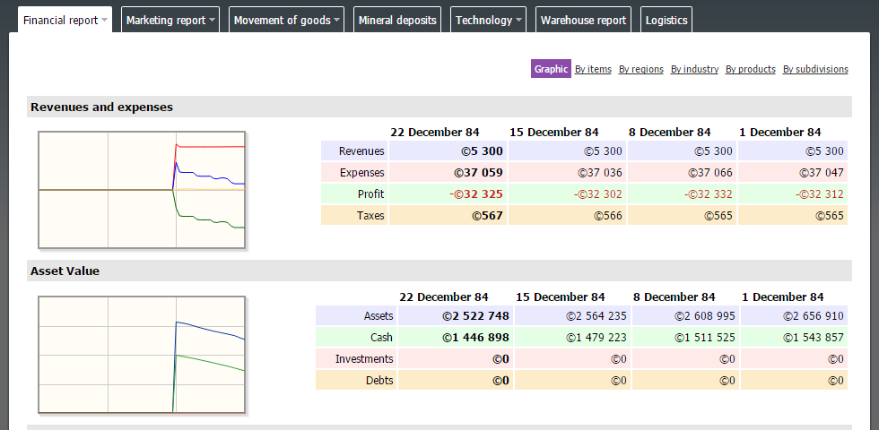

**What are the financial results of each of my subsidiaries?**

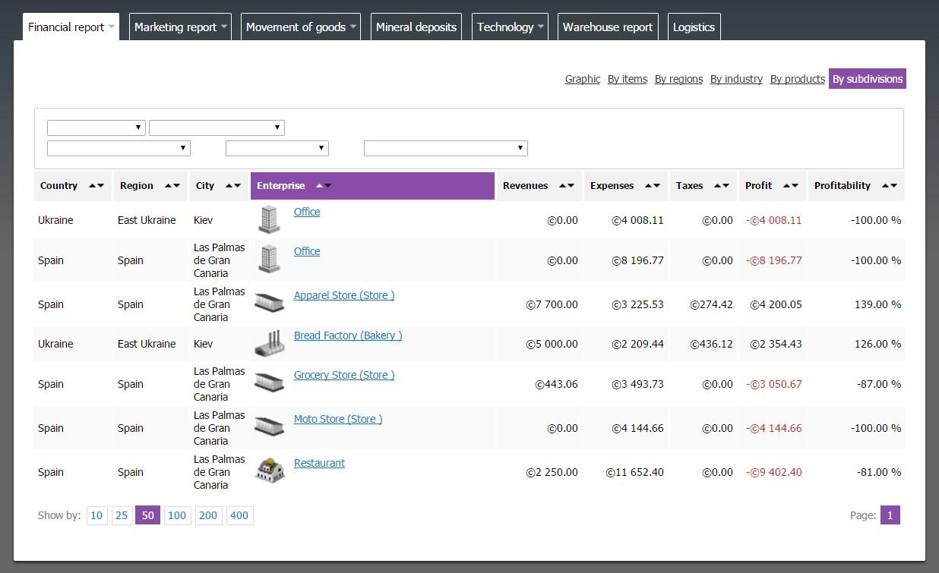

## What have I done/failed to do to bring my virtual business out of crisis?

* Crisis / strategic management decisions:
* Production management decisions:



* Supply management decisions:
* Marketing decisions (Place, Product, Price, Promotion):



* Resource (HR, FM, logistics, R&D, etc.) management decisions:

## Self-assessment - my learning experience:

* Marketing analysis –
* Supply chain management –
* Decision making –
* Production management –
* Quality management –
* Establishing of product, place, pricing and promotion –
* Logistics -
* International trade (customs, taxes, etc.) -
* Personnel management -
* Investment and finance management -
* Value chain management -